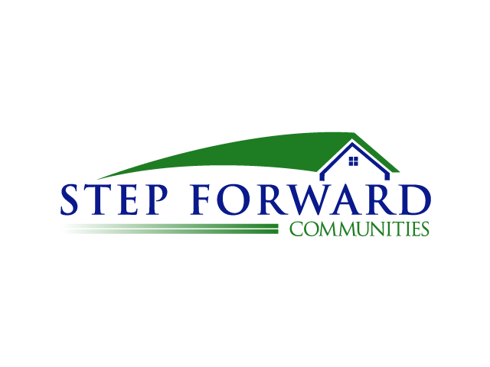

638 Camino De Los Mares
Suite H130-467
San Clemente, CA 92673
949-216-0210

March 14, 2012

Subject: Volunteer opportunities in affordable housing communities

Dear volunteers,

Step Forward Communities is the social services coordinator for multiple affordable housing properties throughout California and Texas. These communities are for senior citizens and low-income families. We are looking for mature, dedicated volunteers who would be interested in serving in these environments. This is a great opportunity to serve your community and impact peoples lives.

If you are interested, read the volunteer standards of conduct, then fill out and sign the attached volunteer form and return it to:

Step Forward Communities
Attention: Duane Henry
638 Camino De Los Mares
Suite H130-467
San Clemente, CA 92673

Or scan and email to:
duane.henry@stepforwardcommunities.com

Step Forward Communities is a California Non-profit organization dedicated to developing and providing social services for low-income housing communities. We are working with developers throughout the state and focus on rural neighborhoods. Our Mission statement is to transform resident’s lives by partnering with ethical, highly motivated companies, organizations and communities to serve the need of affordable housing and social services for low-income families, seniors and veterans.

If you have any further questions, please contact Duane at (949) 216-0210

Respectfully,

Duane Henry
Executive Director

